State of the smallholder coffee farmer

# Indicator report

|  |  |
| --- | --- |
| Indicator | Proportion of farm area in coffee |
|  |  |
| Definition | Ration between the area of land under coffee production manged by the smallholder farmer and the total amount of land managed by the farmer. This may include under different types of ownership and right of access. It excludes areas not cultivated |
| Indicator unit | % |
|  |  |
| Internal indicator code | F44 |
| Member of | Key farm characteristics |
|  |  |
| Countries included | Guatemala |
|  | Honduras |
|  | Nicaragua |
|  |  |
| Years included | 2015 |
|  | 2016 |
|  | 2017 |
|  | 2018 |

# Summary of indicator values

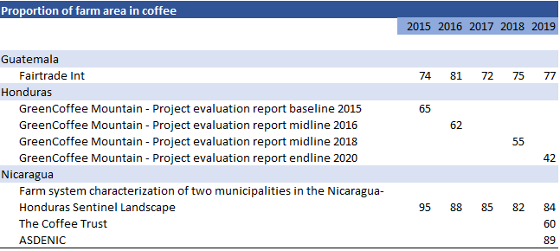

Indicator values are presented in a different row when the source varies. See data download for more information about sources.

# Country comparison

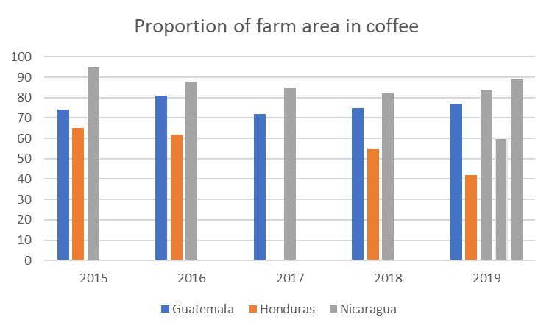

# Indicators over time by country

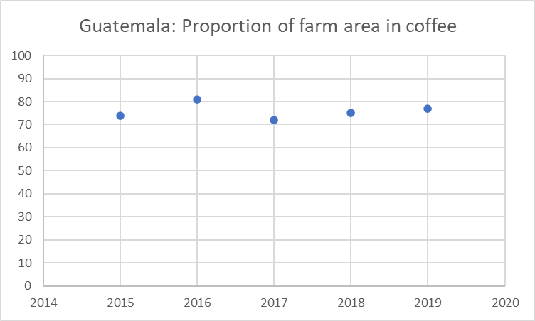

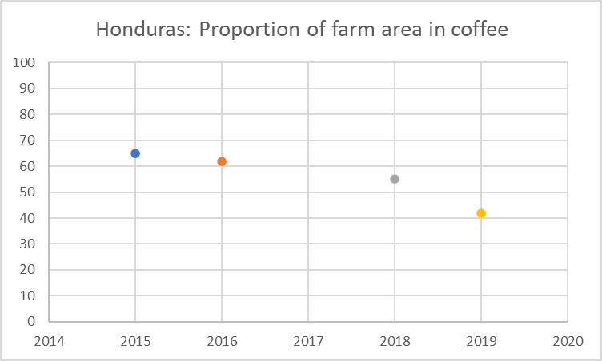

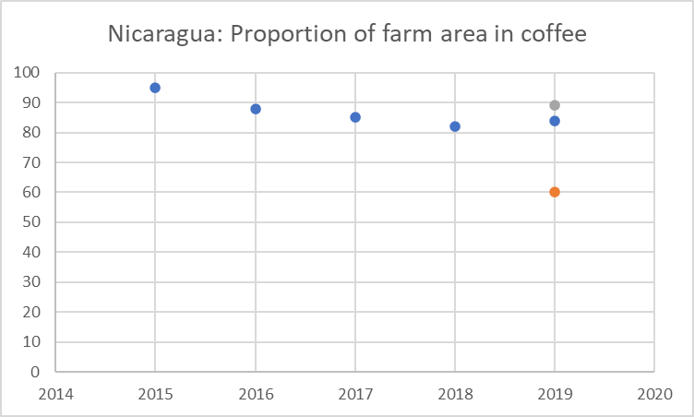

|  |  |
| --- | --- |
| Definitions by Source | |
|  |  |
| Fairtrade Int | Ration between the area of land under coffee production manged by the smallholder farmer and the total amount of land managed by the farmer. This may include under different types of ownership and right of access. It excludes areas not cultivated |
|  |  |
| GreenCoffee Mountain - Project evaluation report baseline 2015 | Ration between the area of land under coffee production manged by the smallholder farmer and the total amount of land managed by the farmer. This may include under different types of ownership and right of access. It excludes areas not cultivated |
| GreenCoffee Mountain - Project evaluation report endline 2020 | Ration between the area of land under coffee production manged by the smallholder farmer and the total amount of land managed by the farmer. This may include under different types of ownership and right of access. It excludes areas not cultivated |
| GreenCoffee Mountain - Project evaluation report midline 2018 | Ration between the area of land under coffee production manged by the smallholder farmer and the total amount of land managed by the farmer. This may include under different types of ownership and right of access. It excludes areas not cultivated |
| GreenCoffee Mountain - Project evaluation report midline 201815 | Ration between the area of land under coffee production manged by the smallholder farmer and the total amount of land managed by the farmer. This may include under different types of ownership and right of access. It excludes areas not cultivated |
|  | Ration between the area of land under coffee production manged by the smallholder farmer and the total amount of land managed by the farmer. This may include under different types of ownership and right of access. It excludes areas not cultivated |
| Farm system characterization of two municipalities in the Nicaragua-Honduras Sentinel Landscape | Ration between the area of land under coffee production manged by the smallholder farmer and the total amount of land managed by the farmer. This may include under different types of ownership and right of access. It excludes areas not cultivated |
| The Coffee Trust | Ration between the area of land under coffee production manged by the smallholder farmer and the total amount of land managed by the farmer. This may include under different types of ownership and right of access. It excludes areas not cultivated |
| ASDENIC | Ration between the area of land under coffee production manged by the smallholder farmer and the total amount of land managed by the farmer. This may include under different types of ownership and right of access. It excludes areas not cultivated |